FRC Alliance Selection Script 2026

** The MC runs the Alliance Selection on the playing field. The Alliance Selection is an important part of the event for both teams and audience, and should be presented with as much energy, enthusiasm, and professionalism as the rest of the event. Emcees must exactly follow the timing and wording outlined below to meet required ceremony timing and must mention the sponsors (Walt Disney Imagineering sponsors the Alliance Selection, and CAT sponsors the Playoffs).The playing field should be preset with the 8 Captain armbands arranged in two rows of four: four armbands across the front of the field, and four across the back. Fuel will be removed for the Alliance Selection.

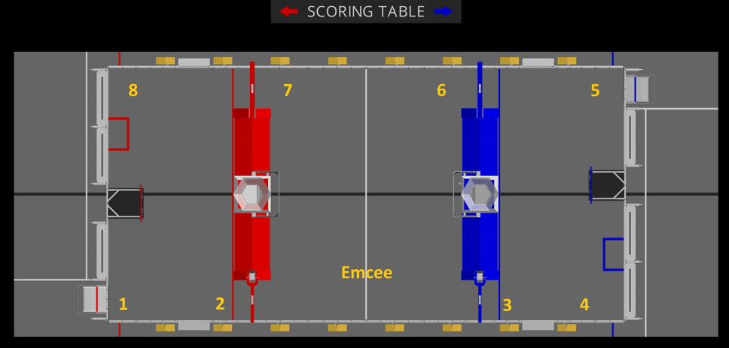

EMCEE
We’ve had a great competition so far with plenty of exciting Qualification Matches, let’s hear it for all the teams competing! Soon we move on to the Playoff Tournament presented by CAT, where eight Alliances of three teams each will compete against each other in a double elimination format to become the Champion here in _________________. But before we begin the Playoffs we need to create the eight Alliances. Let’s roll the Alliance Selection video which explains the selection process.
roll Alliance Selection video

We’ll be back in a few minutes – when the timer hits zero – to begin the Alliance Selection, presented by Walt Disney Imagineering. Now let’s check out the schedule for this afternoon and the Rankings.

Music plays, roll Playoff and Awards Schedule video, then roll rankings until Alliance Selection begins

----- START of SELECTION ROUND 1-----

EMCEE
Welcome to the Alliance Selection, presented by Walt Disney Imagineering! Before we begin, a few reminders for all the Alliances:
- Pay close attention to the timers displayed here on the playing field.
- The Alliance Captain must approach me here in the center of the field to announce their pick before the timer reaches zero.
- During the first round of selections Alliances will have a 45 second limit to make their pick. When your Alliance is ready, the student Alliance Captain only must come to me to announce the pick.
- And any team that declines an invitation may not be selected by another Alliance.

Now let’s meet the number 1 ranked team, with a record of ___ wins and ___ losses please welcome Team # ______________
(Game Announcer announces Team nickname and hometown the first time a Team Rep runs onto the field. If they are a captain, the MC places the Team Rep on the Field by the appropriate Alliance Capt. cap/arm band- which have been preset. The Number 1 Seed should be positioned near the Red Alliance Driver Station #3 – see diagram.)

EMCEE
Alliance 1 you are now on the clock, when you’re ready, let me know who you’d like to select.
(the pick timer begins to run)

If they make a pick:

- MC should repeat the Team number. The Game Announcer should announce Team nickname and hometown as each selected Team Rep runs onto the field.

- As a Team representative comes up to accept or decline, make sure they speak into the microphone so the audience can hear.

- If a Captain selects a team that would otherwise be in a captain position, use this phrasing to the invited Team: “Would you prefer to join or form your own Alliance?”

- If the pick accepts:
  - Say “Congratulations” and repeat this process if there are remaining captains to introduce by going back to the “Start of Round 1” marker above.
- If the pick declines:
  - Say “Alright, let’s reset that pick timer for you. Let me know when you are ready to invite another team.”

If they do not make a pick:

- Say “It looks like time has expired.”
  - If this is the last pick in this round:
    - Say “As this is the last pick in this round, this will be an automatic selection. Please welcome the next highest seeded Team #________ to Alliance #_______”
  - If this is not the last pick in the round:
    - Say “We’re going to skip this Alliance for now, and they’ll have a chance to pick after the next Alliance selects a team.”

AFTER bringing out the Alliance 8 Captain and BEFORE starting the timer,
and ONLY IF there are NO outstanding picks, say:
Alright, and with that, Alliance 8, you are now on the clock. Who would you like to select?

If outstanding picks, wait for their pick and follow the same process as above upon Accept or Decline or Automatic Pick.

That concludes our first selection round. Before we begin round two, the Alliances have 2 minutes to confer. Then we’ll begin selections with Alliance 8. While they talk, let’s look at the generous companies who help support FIRST Robotics Competition.

(play music, roll FRC Supplier video -- 2 minute Timer begins)

----- START of SELECTION ROUND 2 -----

EMCEE
We’re about to see the strategies of these Alliances play out as they look to partner with teams whose robot complements their own to create the strongest possible Alliance. The eight Alliances will compete in the double elimination Playoff Tournament, leading to a best two out of three set of Finals matches later this afternoon.

During the second round of selections all teams have a 90 second limit to make their pick. Alliance 8 you are now on the clock, who would you like to pick?

When they make a pick:

- MC should repeat the Team number. The Game Announcer should announce Team nickname and hometown as each selected Team Rep runs onto the field.

- If the pick accepts:
  - Say “Congratulations” and repeat this process until you get to Alliance 1.

- If the pick declines:
  - Say “Alright, let’s reset that pick timer for you. Who would you like to invite next?”

If they do not make a pick:

- Say “It looks like time has expired.”
  - If this is the last pick in this round:
    - Say “As this is the last pick in this round, this will be an automatic selection. Please welcome Team #________ to Alliance #_______”
  - If this is not the last pick in the round:
    - Say “We’re going to skip this Alliance for now, and they’ll have a chance to pick after the next Alliance makes their selection.”

BEFORE THE FINAL PICK:

EMCEE
There is one spot left in the Tournament. After our Number 1 Seed makes their final selection, there is still a chance that the next eight highest ranking unselected teams could compete. If a robot becomes non-functional during the tournament each Alliance has one opportunity to substitute in a robot from the backup pool. Alliances do not get to select which backup team comes in to their Alliance, the backup teams will come in by ranking order, starting with the highest ranked remaining team.

We’ll need the student representatives from the backup teams to confirm their participation in the Playoffs with the Lead Queuer standing by (indicate the Lead Queuer) in just a moment.
(The Lead Queuer should be standing off the field with the line of Team Reps.)

But now it’s time to find out who Alliance number 1 would like as a member of their Alliance. Alliance 1, you are on the clock, who would you like to select?

After all eight complete Alliances have been created:

EMCEE
Well done. This looks to be an exciting tournament. Let’s have a round of applause for all the teams competing here in _________________. If you weren’t selected for the Playoffs, pick an Alliance to cheer on!

Now we need all Alliance Captains to stay here on the field to meet with the Head Referee to review Playoff rules. It is now allowed to swap out the Alliance Captain if needed.

All backup teams, that’s Team ________ thru _________(read the Team numbers from the list on the Audience Display screen), please confirm your willingness to compete in the Playoffs, if called upon, with the Lead Queuer in the Team Rep area.

We’re going to let the Alliances strategize and prepare for the Playoff Tournament which will be starting at _______pm.

We will be presenting many awards between the Playoff rounds and will have the Closing Awards Ceremony immediately following the Playoff Tournament.

We’ll see you back here to get things started in just a bit – and don’t forget to bring your Gracious Professionalism - Thanks everyone!

(play lunch break music and video rolls)

